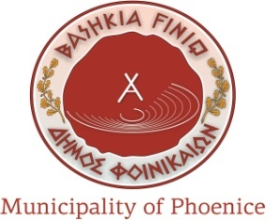
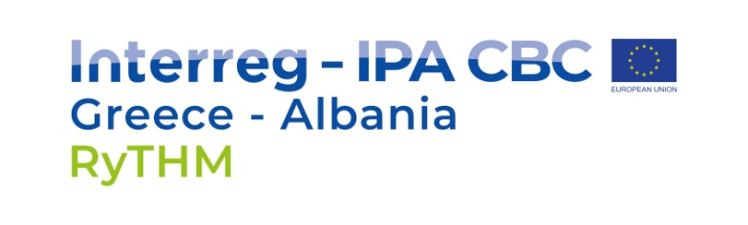

SUBJECT: TENDER ANOUNCEMENT

Livadhja – Cultural Center Equipment, Del 3.3.4 “RyTHM” – Project FosteringCreativity and Connecting Cultural Assets through Monuments

REF No 02

The Municipality of FINIQ, intends to award a supply contract for Livadhja – Cultural Center Equipment, Del 3.3.4 “RyTHM” – Project, Fostering Creativity and Connecting Cultural Assets through Monuments in LIVADHJA with financial assistance from the INTERREG IPA CBC Greece – Albania 2014 -2020.

The tender dossier is available from Municipality of Finiq in CD Rom to all the companies or consortiums of companies that are interested to participate for this tender. The terms of references and instruction for tenderers will be published in Official web page of Finiq Municipality, Official webpage of our external expert AULEDA – Local Economic Development Agency as well as in the Local TV.

Also, the tender announcement will also be published on the website of DG International Cooperation and Development:
https://webgate.ec.europa.eu/europeaid/online-services/index.cfm?do=publi.welcome].
The deadline for submission of tenders is 20 May 2020
Possible additional information or clarifications/questions shall be published on the website of Contracting Authority as well as to the following responsible person.
VELTA DALANAJ
Municipality of Finiq
FINIQ, Kodi postar 9716
Tel +355 686055695
E-mail: bashkia.finiq@gmail.com, bfiniq.euprograms@gmail.com

